SoulsLike/Forsaken

DESIGN DOCUMENT

By Braison 2025

**Introduction** **2**

Game Summary 2

Inspiration 2

Player Experience 2

Platform 3

Development Software 3

Genre 3

Target Audience 3

**Concept** **3**

Gameplay overview 3

Theme Interpretation (Sacrifice Is Strength) 4

Primary Mechanics 4

Secondary Mechanics 5

**Art** **6**

Theme Interpretation 6

Design 6

**Audio** **7**

Music 7

Sound Effects 7

**Game Experience** **7**

UI 7

Controls 7

**Development Timeline** **8**

## image

## Introduction

### Game Summary Pitch

SoulsLike is a 2D game focused on combat, exploration and subtle storytelling

### Inspiration

**DarkSouls**

An exploration game that has very good combat, art and music,interesting platforming ideas , enemies ,npc’s e.t.c

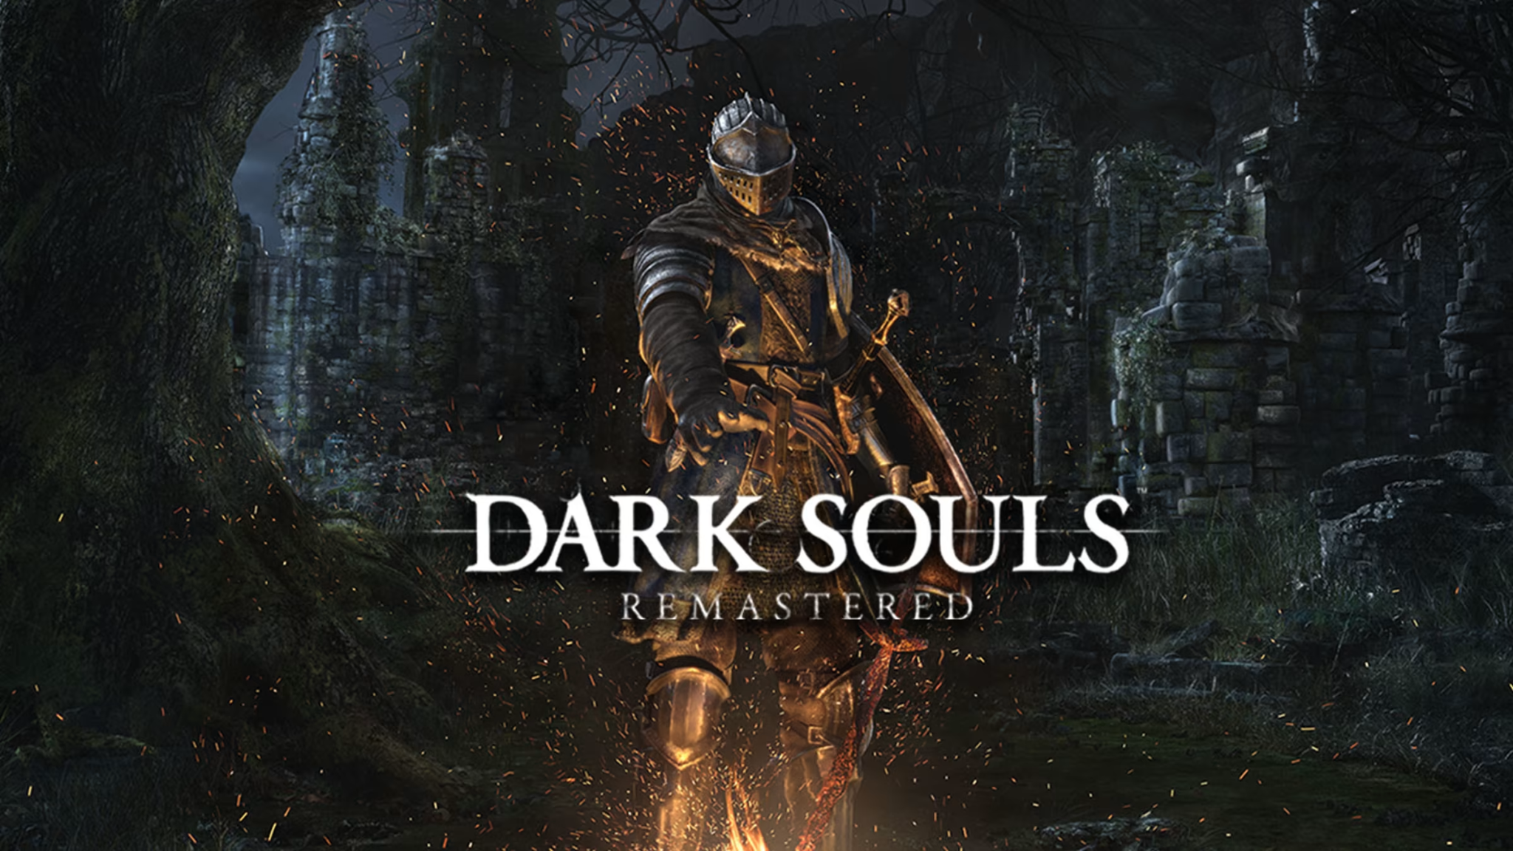

**Dead Cells**

2d platformer , limited health and regeneration options , exploration, really good visuals , combat and music. Very good gameplay overall . The game also provides a fun challenge that feels surmountable.

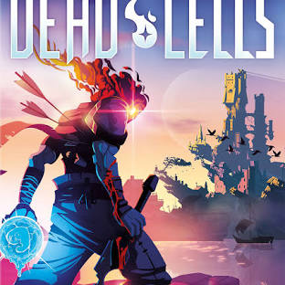

### Player Experience

In a single screen dungeon for each of the **10 levels**, the player will fight enemies then a boss at the end. Upgrades along the way , enemies give you points to upgrade ur stuff, boss gives you smth to upgrade ur stuff even more.

Managing health, stamina and menergy(magic energy)

### Platform

The game is developed to be released on windows PC

### Development Software

* Gamemaker Studio version 2.3 for programming
* Aseprite for graphics and UI
* Lmms and others for all music and SFX

### Genre

Singleplayer, action/adventure,fantasy

### Target Audience

Without heavy or complicated ideas, and intuitive-to-grasp mechanics, this game is marketed to at least **casual game players** who are up for puzzling challenges as well as more veteran players up for solving complicated problems

## Concept

### Gameplay overview

The player controls an avatar of a champion of bright , fight and clim out of the abyss , find out the 7 kings are behind all this, fight them one by one free your people

### Theme Interpretation (overcoming difficulty)

Explore different areas and find items, set respawn points yourself(bonfire type mechanic), where player rests, repairs weapons and armor , inventory mgmt, fight enemies with different types and attacks, weaknesses and strengths that fit that area lorewise

### Primary Mechanics

| **Mechanic** | **Animated Mockup**  ***(Art not necessarily final)*** |
| --- | --- |
| **Walls** a  A stopping force to prevent a player too large to access a certain area. Otherwise to simply restrict movement.  For walking also. |  |
| **Spikes** a  When a player cell walks on top of a spike they take damage. |  |
| **Holes** a  The player mass can walk freely over a hole as long as at least one cell is on a floor tile. If the entire mass is over the hole, the entire player mass dies. |  |
| **Brightstone**  This is the bonfire mechanic in the game , for resting , healing, upgrading weapons(maybe) |  |
| **Platforming**  to avoid traps, -> blades, holes , projectiles  managing stamina and its regeneration through -Dodging or blocking enemy attacks, Timing attacks, strafing,  judgement - learning when to dodge or when not to ,managing regeneration of health , menergy and stamina. Observing enemy attacks, learning them overcoming their challenge |  |

### Secondary Mechanics

## Art

### Theme Interpretation

While maintaining the very limited color palette theme, the sole use of black in white seems way too common, and a bit harsh as a color scheme for a relaxing puzzle game. To circumvent this, a soft, **dark blue color** will act as the unique accent color as opposed to black with white being the primary, carrying color to base the sprites off of. 

### Design

A very **minimalistic** approach will go into the design of the game, heavily relying on the severe contrast of the limited colors to provide detail. Though, the design still is clean and smooth in the sense that, the use of many shades of a color will not be as present to confront the **retro style** and pixel art.

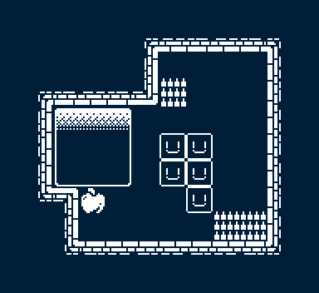

*\*Not an actual puzzle/level, merely a full example of the tileset and art style\**

## Audio

### Music

To add to the overall theme and vibe of the game, there will be minimalism incorporated into the music. Heavy use of reverb and effects to fill space within the few instruments. Bass and drums will generally constitute the majority of tracks with accompanying softer sounds. Mainly through synthesized sounds rather than acoustic will further suggest the retro style.

### Sound Effects

To add more flare and polish to the experience, a multitude of environmental sound effects will give weight and feedback to the player’s actions. Rather than foley, or otherwise realistic sounds, synthesized blips, bloops, and whooshes are used.

## Game Experience

### UI

On top of the rigid pixel art constituting the rest of the art, a more smooth, higher definition style will be incorporated in the UI. Utilizing many shades of white and black allowed in the art restriction, anti-aliasing is used to further emphasize the UI.

### Controls

**Keyboard**

Arrow keys / WASD  
**Gamepad**

Dpad

## Development Timeline

**MINIMUM VIABLE PRODUCT**

| **#** | **Assignment** | **Type** | **Status** | **Finish By** | **Notes** |
| --- | --- | --- | --- | --- | --- |
| 1 | Design Document | Other | Finished | Jun 22, 2022 |  |
| 2 | Create player and wall assets | Art | Finished | Jun 23, 2022 | Prototype for GDD is done |
| 3 | Main menu theme | Audio | Finished | Jun 23, 2022 | Can be really short, player won’t be on main menu for long |
| 4 | UI / Main menu | Coding | Finished | Jun 23, 2022 | Button UI, screen transition, title screen |
| 5 | Level theme | Audio | Finished | Jun 24, 2022 | Should be more substantial and not annoying |
| 6 | Simple player movement | Coding | Finished | Jun 23, 2022 | Move single cells around and collide with walls |
| 7 | Complex player movement | Coding | Finished | Jun 24, 2022 | Multi cell masses act together to collide with walls |
| 8 | Spikes and holes with player interactions | Coding | Finished | Jun 24, 2022 | Implement spike and holes mechanics |
| 9 | Fruit interaction | Coding | Finished | Jun 25, 2022 |  |
| 10 | Special effects | Art | Finished | Jun 25, 2022 | Dust particles during movement |
| 11 | Player animation | Art | Finished | Jun 25, 2022 | Idle blinks, movement polish |
| 12 | Sound effects | Audio | Finished | Jun 25, 2022 | Player movement, UI interaction |
| 13 | Pause menu | Coding | Finished | Jun 26, 2022 | Access to the main menu or resetting the level |
| 14 | Level select menu | Coding | Finished | Jun 26, 2022 |  |
| 15 | Level design (1-7) | Other | Finished | Jun 27, 2022 | Create levels 1 through 7 |
| 16 | Level design (8-15) | Other | Finished | Jun 28, 2022 | Create levels 7 through 15 |
| 17 | Any extra polish | Other | Finished | Jun 29, 2022 |  |
| 18 | SUBMIT | Other | Finished | Jun 29, 2022 | Create Itch Page and upload |

**BEYOND (if ahead of schedule / extra time)**

|  |  |  |  |
| --- | --- | --- | --- |
| Undo | Other | Not started | At any point, the player may undo their move, any movement, creation, or destruction of a player cell is reversed |
| Extra levels | Other | Not started |  |
| Settings Menu | Coding | Finished | Volume slider, fullscreen toggle |

### 👍 What’s already solid

* **Clear inspirations** (Dark Souls, Dead Cells) — good anchor points.
* **Defined loop**: fight → explore → upgrade → boss → repeat.
* **Core mechanics** (walls, spikes, holes, stamina/magic/health).
* **Bonfire mechanic (“Brightstone”)** — instantly gives Soulslike vibes.
* **Minimalist pixel art direction** — achievable solo and consistent with your tools (Aseprite).
* **MVP breakdown** — you already structured your milestones like a pro.

### 🔧 Areas you could refine

1. **Combat Depth**  
   Right now your doc mentions “attacks, dodge, block” but doesn’t go deeper.  
   → Suggestion: Define **attack types** (light/heavy?), stamina costs, parry mechanics, enemy poise.
2. **Progression System**  
   You mention “points to upgrade” but don’t specify what.  
   → Suggestion: Lay out upgrade categories (HP, stamina regen, weapon dmg, spell slots, etc.).
3. **Boss Design Philosophy**  
   You said “10 levels, boss at end” — cool. But what makes each boss unique?  
   → Suggestion: Add one-line “identity” for each boss (Ex: “King of Chains — grabs & constrains movement”).
4. **Lore & Subtle Storytelling**  
   Soulslikes shine with environmental storytelling.  
   → Suggestion: Note how you’ll use tiles, enemy placement, or background art to hint at the fallen kingdom.
5. **UI/UX polish**  
   You want clean UI with anti-aliasing (nice idea) → Just be mindful it doesn’t clash too hard with your pixel art.

### 🔮 Next Moves in Dev

Since you already have **player, walls, and movement**:

1. Add **stamina + basic attack system** (swing + cost + regen).
2. Prototype **one enemy with telegraphed attack pattern**.
3. Add **Brightstone checkpoint** → heal + respawn.
4. Then build out your **first real combat room** to test the core loop.